

***INSTITUTE OF INFORMATION TECHNOLOGY***

***JAHANGIRNAGAR UNIVERSITY***

**Number of Assignment :** 01

**Submission Date :** 02/01/2024

**Course Tittle :** Digital Image Processing Lab

**Course Code :** ICT - 4202

**Submitted To Submitted By**

Mehrin Anannya Md. Shakil Hossain

Assistant Professor Roll – 2023

IIT – JU 4th year 2nd Semester

IIT – JU **Task: 1**

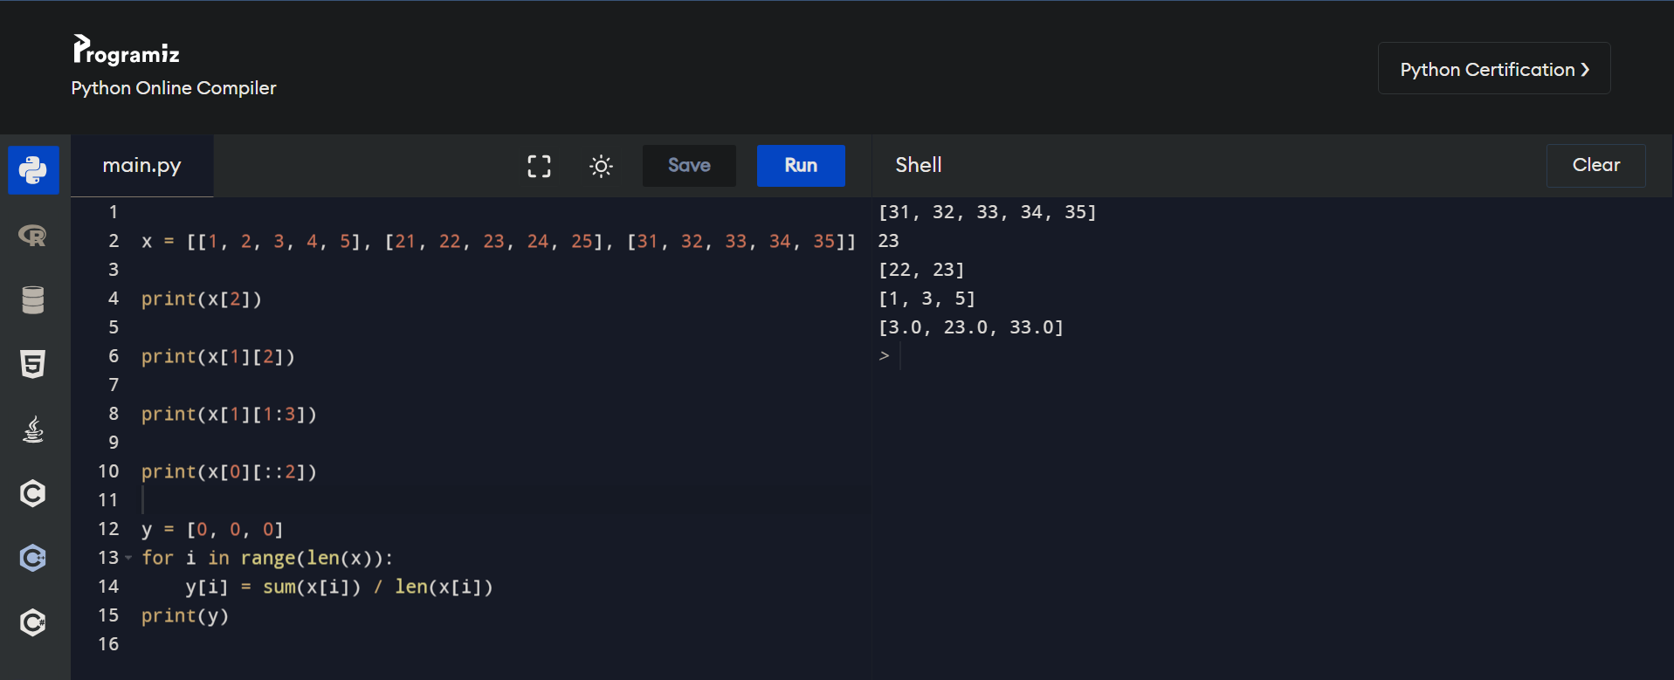

**Task: 2 (a)**

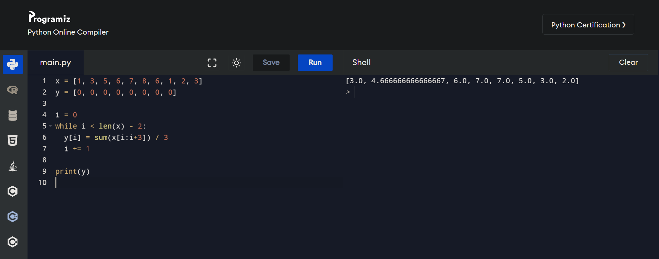

**Task: 2 (b)**

